|  |
| --- |
| rEGGAErunningz LIMITED |
| 3D First Person Shooter |
| **GAME PROGRAMMING1 ASSIGNMENT3** |
| Version 1.03  All work Copyright © 2015 by ReggaeMuffinz Games.  All rights reserved. |
| **HuAndre Barrett** |
|  |



**Insert a Company Logo here**

|  |
| --- |
| Nov 20th 2015 |

**Table of Contents**

Contents

Version History 3

Game Overview 4

Game Play Mechanics 4

Camera 4

Controls 4

Menu and Screen Descriptions 5

Enemies 5

Items 5

Vehicles 5

Script 6

Scoring 6

Sound Index 6

Art / Multimedia Index 6

Future Features 6

# Version History

The Github repository can be found here <https://github.com/cencolhubar/3DAssignment>

# 

# Game Overview

*The game consists of a First Person shooter on a tropical island that is shooting at a pack of dinosaurs that are roaming the island. There dinosaurs are streaming into an enclosed section of the island that has gold coins placed randomly around it.. The object of the game is for the player to shoot the dinosaurs, collect the coins and avoid colliding with the dinosaurs.*

# Game Play Mechanics

*The game is shown from a first person shooter perspective. The player’s weapon is in the right hand corner of the screen. You can use the left, right, up or down arrow to move the player in any direction. You also use the mouse button to turn the player to face a particular direction. Use the arrow keys or WASD and the mouse to direct the player over the coins. Use the arrow keys to avoid the dinosaurs. When coins are collected your points increase. Your points are displayed on your screen as you play. When you collide with a dinosaur you lose points. After you lose three points the game is over. The option to restart your game by pressing the R button shows up on the screen when you die.*

# Camera

*Main camera-3D first person shooter perspective*

*Gun Camera – for showing and firing the gun*

# Controls

*Arrow keys to direct the player*

*Left mouse button shoots the gun*

*Use mouse to change direction player faces*

# Menu and Screen Descriptions

*IN GAME SCREENSHOT*

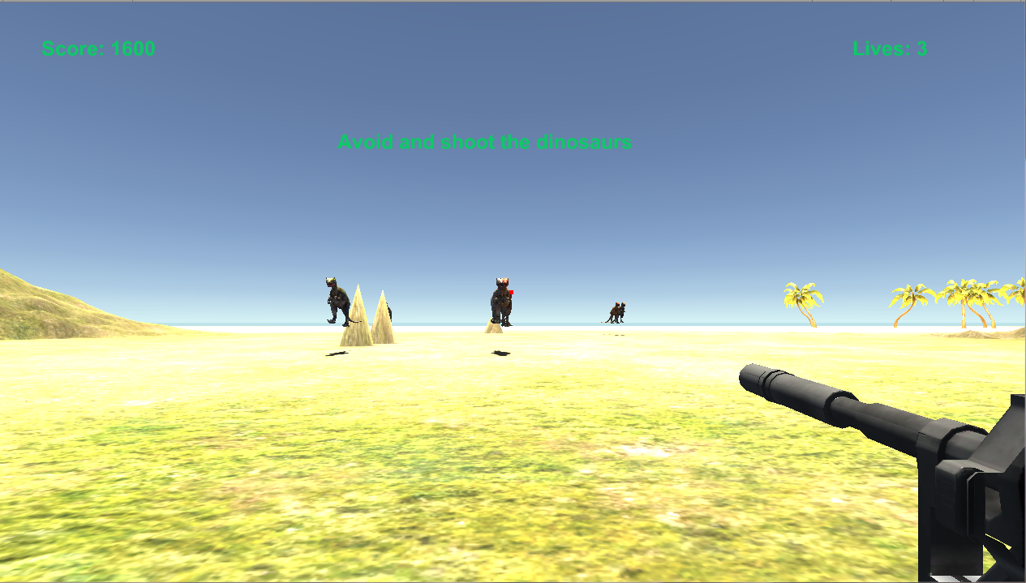

*POST GAME SCREENSHOT*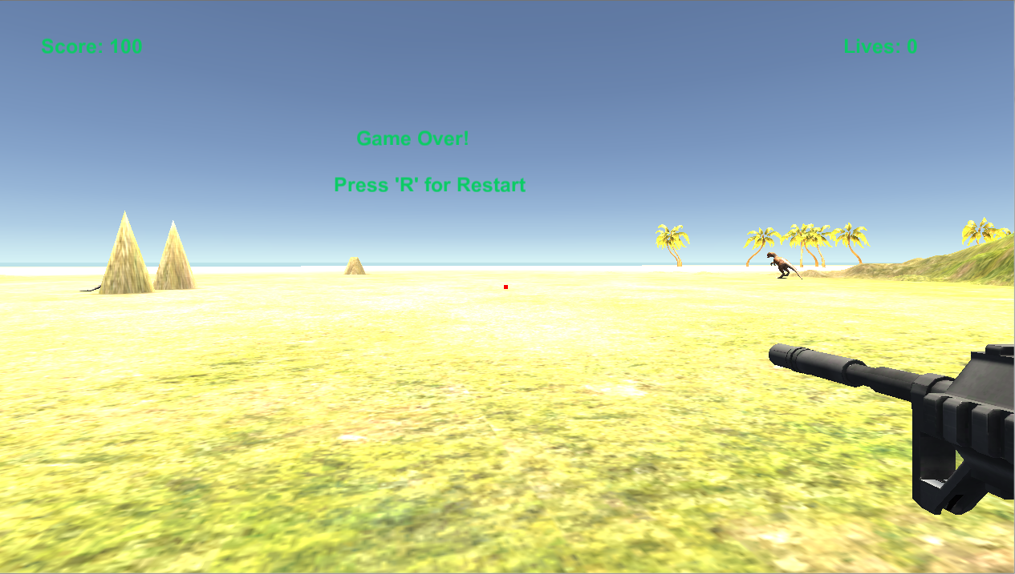

*PRE GAME SCREENSHOT*

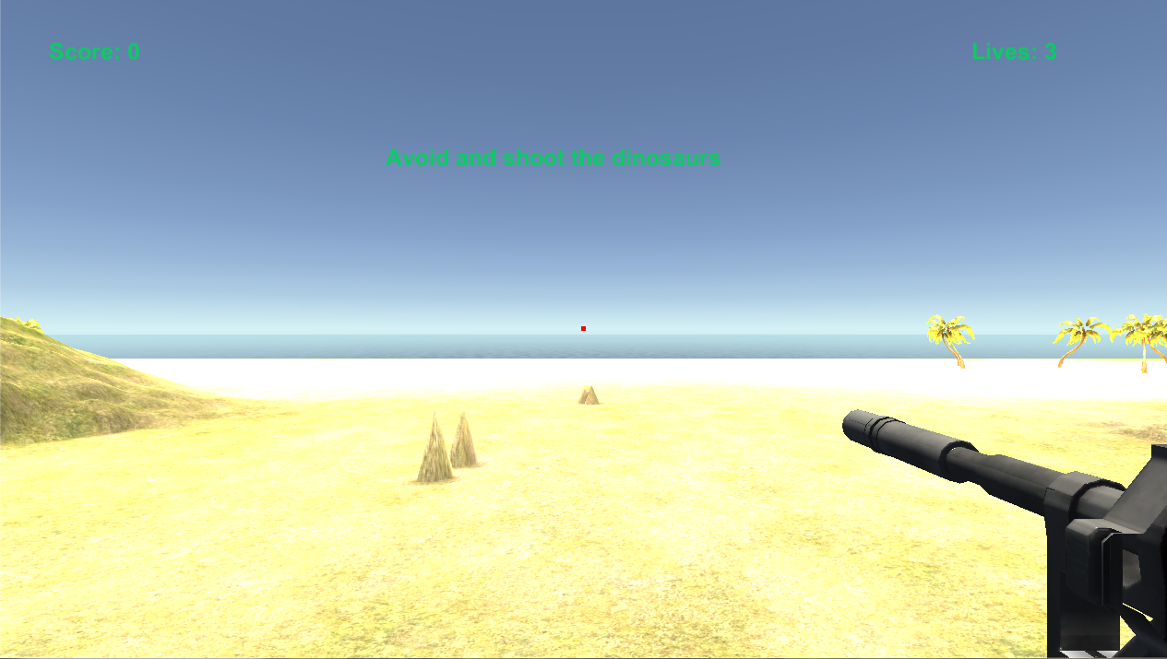

# Enemies

*The dinosaurs are the enemies in the game and they kill the player if collided with*

# Items

*The player collects gold coins to increase his score*

# Player

The main player is the first person shooter

# Script

..\3D Assignment\Assets\_Scripts

# Scoring

Player points increase by 1000 each time they collect a gold coin

Player points increase by 100 each time they shoot a dinosaur

# Sound Index

.. \3D Assignment\Assets\Audio

* **Taken from Youtube**
  + ☥ Here Comes Trouble Instrumental Chronixx Rootsman Riddim Version +Lyrics
* **Taken from Unity Asset Store**
  + Dinosaur roar - Sound Effect
  + flesh_bullet_impact-1
  + mp5_fire-1

# Art / Multimedia Index

*The following graphic assets were taken from unity 3d store*

* MP5 Gun Asset
* Allosaurus dinosaur asset
* Unity standard asset pack
  + WaterDaytimePro
  + SpeedTrees

# Future Features

*Implementation of other enemy shooters for the player to kill*